

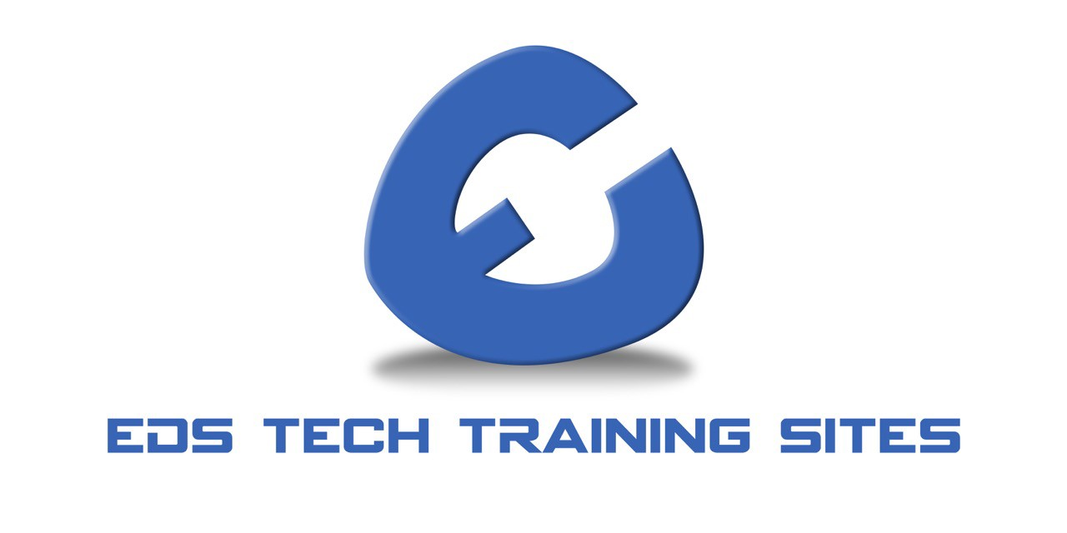

CAPABILITIES
&
PRESENCE
DUNS:
080692449
CAGE:

7
RE
88
NAICS:
611710
Educational Support
NAICS:
237130
Fiber Optic Cable
Transmission Line
Construction
NAICS:
238210
Security and Fire
System Installation

MISSION STATEMENT:
Retrain America understands that jobs requiring skill training are the backbone of our economy.

Every year over 400k military service men and women transition from military service into the civilian sector. Those transitioning veterans are
DUNS:
080692449
CAGE:

7
RE
88
NAICS:
238210
Security and Fire
System Installation
NAICS:
237130
Fiber Optic Cable
Transmission Line
Construction
NAICS:
611710
Educational Support
MOTTO:
entering into vast and ever-evolving economy. They have a vital need to secure employment, pursue education, specialized training and/or entrepreneurship.
Our mission is to provide quality skills training so that veterans have access to better employment opportunities and local business see sustained growth.
Retrain America plans to contribute through expert analysis, technical assistance, bro ad-based organizing, targeted advocacy, cutting-edge communications and by investing in innovative partnerships with industry education and workforce leaders.
Retrain America will bring added value change into urban and rural underprivileged communities by providing nontraditional tools such as e-learning, flex schedules for training and wraparound services to balance work and learning.
We combine the operations of our non-profit (Retrain America) with our for-profit (EDS Tech Training Sites, LLC) to provide quality world class workforce training.
Retrain America promises to deliver workforce training and employment services by providing competitive solutions, connecting Veteran’s and employers through a network of authorized job centers, community training centers and retraining sites.
CAPABILITIES:
- Convenes a workforce dialogue critical to economic development • Collaborates with national, state, and local leaders in education, workforce development, business, technology, government, and philanthropy • Develops powerful partnerships and networks that help scale our impact
- Engage employers and offers premier workforce solutions
- Provides comprehensive solutions to employment for job seekers
DIFFERENTIATORS:
- Established relationships with key local, state and federal officials • Established relationships with key workforce development agencies and private providers
- Established relationships with community colleges and K-12 Institutions
- Currently providing STEM Training
OUR CLIENTS:
DUNS:
080692449
CAGE:

7
RE
88
NAICS:
238210
Security and Fire
System Installation
NAICS:
237130
Fiber Optic Cable
Transmission Line
Construction
NAICS:
611710
Educational Support
City of Crockett
City of Grambling
City of Prairie View
CTE
Harris County Galveston Area-Council
Houston Area Urban League
Houston ISD
Prairie View A&M University
San Jacinto College
Tomball Police
REGIONS SERVED:
Kentucky Louisiana
Mississippi Oklahoma
Texas Ghana
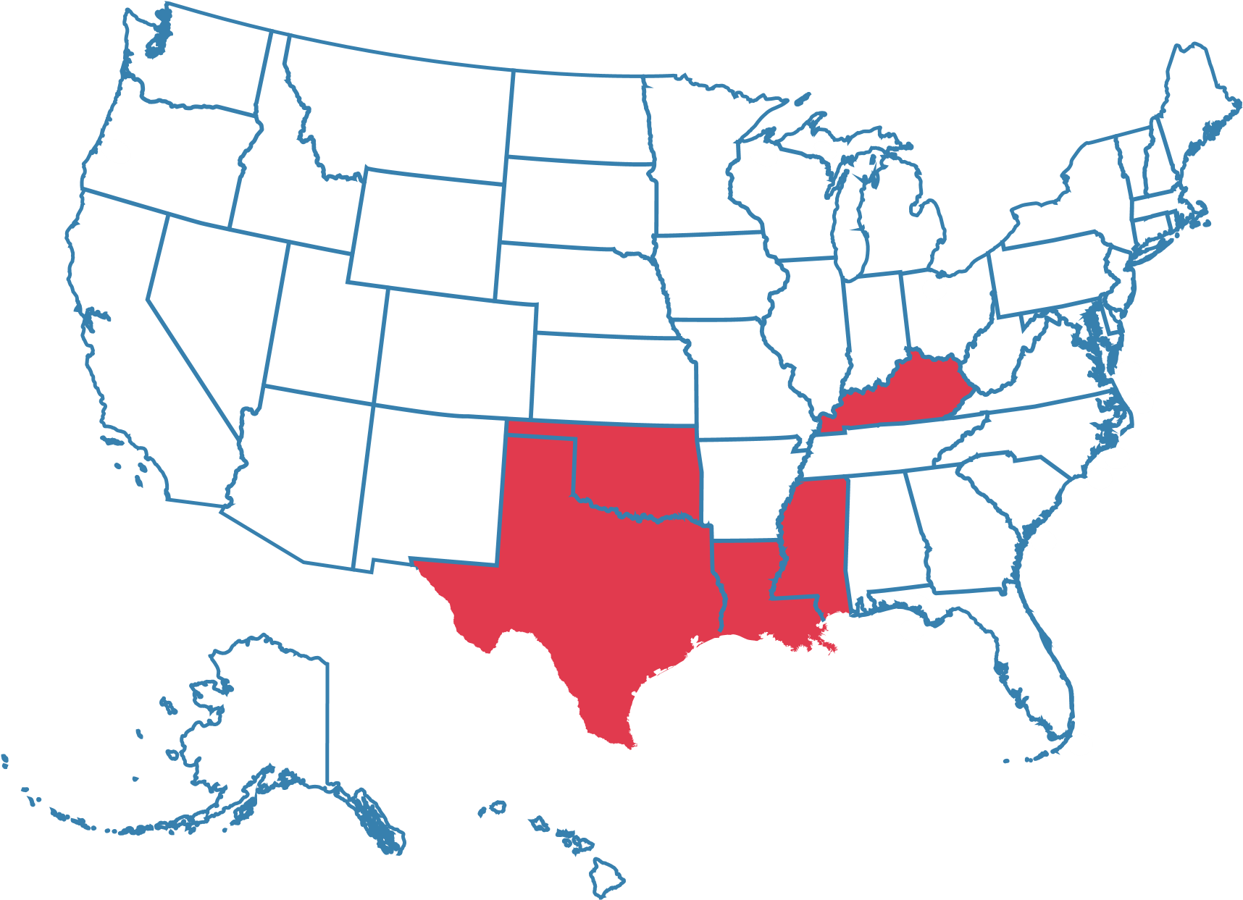
*services available across the USA

DUNS:
080692449
CAGE:

7
RE
88
NAICS:
238210
Security and Fire
System Installation
NAICS:
237130
Fiber Optic Cable
Transmission Line
Construction
NAICS:
611710
Educational Support
REGIONS SERVED continued:
*services available across the USA
$3.5 MILLION
veteran jobs yearly per city
100-500
TEXAS

Houston
Crockett
Priaire View
San Antonio
Brookshire
Montgomery
Blanco
Austin
Dallas
Brownsville
MISSISSIPPI
Cleveland
Mound Bayou
Meridian
LOUISIANA

Grambling
OKLAHOMA
Tulsa
KENTUCKY
Louisville
GHANA
Amasaman
LICENSES:
361 Security Licensed B20275
TWC Career School S5545
CERTIFICATIONS:
ETA Certified

FOA Certified
DUNS:
080692449
CAGE:

7
RE
88
NAICS:
238210
Security and Fire
System Installation
NAICS:
237130
Fiber Optic Cable
Transmission Line
Construction
NAICS:
611710
Educational Support
HUB Certified City of Houston
HUB Recognized & Certified
MWSEBESDVOB
SAMS Recognized
SDVOB Certified
Texas Education Agency
Texas Department of Agriculture
Texas Department of License & Regulations
Texas Veterans Commission
US Veteran Certification Business

CAPABILITIES:
- Fiber Optic Splicing Technician
- Directional Bore Technician
- Telecom Aerial Construction Technician.
- Tower Technician (Coming)
- San Jacinto Community Colleges
CFOT Certified Fiber Optic technician
- Houston ISD



SAP, Coding - UAS , Fiber optic and Agrieconomic
DUNS:
080692449
CAGE:

7
RE
88
NAICS:
238210
Security and Fire
System Installation
NAICS:
237130
Fiber Optic Cable
Transmission Line
Construction
NAICS:
611710
Educational Support
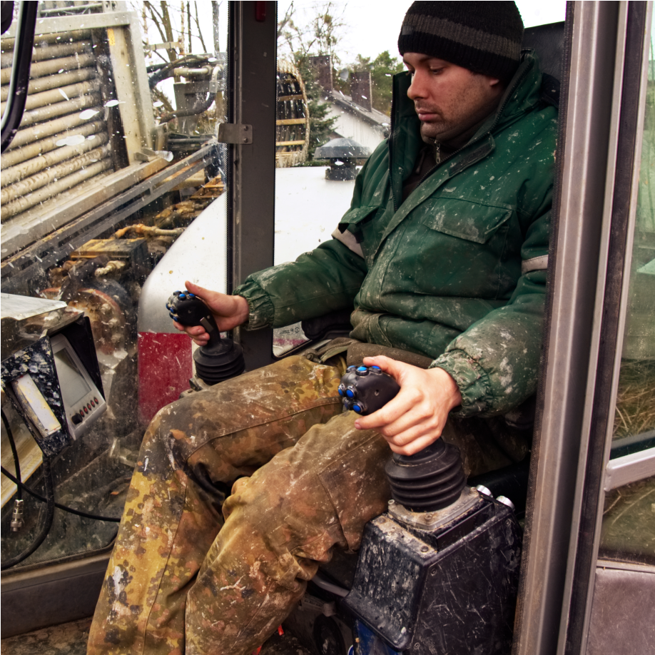
- Houston Community Colleges City of Houston
All Things Telecom Training
Starting 2022
- Comcast Cable / Aspen Utilities
City of LaGrange Texas
Private Industry
Workforce Training
Starting 2022
- City of Crockett EDC
East Texas Regional Training
Starting 2022
PRIVATE PUBLIC PARTNERSHIP (P3):
How does community development work?
US Department of Agriculture (USDA)
US Department of Labor (USDOL)
US Department of Transportation (USDOT)
Texas Education Agency (TEA)
Texas Department of Agriculture (TDA)
Texas Department of Licensing and Regulation (TOLR)
Texas Veterans Commission (TVC)


Texas Workforce Commission (TWC)
DUNS:
080692449
CAGE:

7
RE
88
NAICS:
238210
Security and Fire
System Installation
NAICS:
237130
Fiber Optic Cable
Transmission Line
Construction
NAICS:
611710
Educational Support
ECONOMIC
DEVELOPMENT
COUNCIL
PRIVATE
INVESTMENTS
MAJOR BUSINESS
(
SMALL-MIDSIZE
)
DEVELOPMENT
K-12
COLLEGE
VOCATIONAL
FEDERAL
GOVERNMENT
STATE
CITY/COUNTY
Infrastructure
Permits
Programs
Projects Security
OUR AFFILIATES:


OUR AFFILIATES:
Our affiliate, Gantt Tech provides Space Operations, Space
Operations Engineering, Operational Mission Protection Subject Matter Expertise and consulting services to industry, academia, and national security space entities.
Gantt Tech engineers and specialist bring wealth of operational experience from Air Force Space Command, the National Reconnaissance Office, and the Space Force When you see the Gantt Tech insignia you can trust that the professional wearing it is among the best and most knowledgeable the world has to offer.
CORE COMPENTENCIES:
- Space Operations

- Space Operations Engineering
DUNS:
080692449
CAGE:

7
RE
88
NAICS:
238210
Security and Fire
System Installation
NAICS:
237130
Fiber Optic Cable
Transmission Line
Construction
NAICS:
611710
Educational Support
- Mission Protection
- Space Mission Design (Mission Ops)
CERTIFICATIONS:
 Project Management Professional
 Space Systems Operations (7 Level)
 DevOps

Architecture and Systems Engineering
Engineering Leadership`

OUR AFFILIATES: CERTIFICATIONS:


Our affiliate, Onshore Outsourcing is a leader in rural sourcing and has a similar commitment to workforce development and the creation of sustainable careers in the IT industry.

Onshore is a full-service IT Support provider that offers world class support and has a proprietary, expert designed ITIL processes and procedures, with a special focus on capabilities such as ITSM Consulting, CX Consultation, VIP Service, and Knowledge Management.
DUNS:
080692449
CAGE:

7
RE
88
NAICS:
238210
Security and Fire
System Installation
NAICS:
237130
Fiber Optic Cable
Transmission Line
Construction
NAICS:
611710
Educational Support

CORE COMPENTENCIES:
- 24x7x365
- Advanced Self Service, Self Help & Chat capabilities

- Advanced Support for Microsoft Products
- Customized and Flexible IT Services
- End To End IT Support solutions (Tiers 1 4 )
- Knowledge Management Solutions
- Support 100% U.S. based employing U.S. Citizens and Veterans

OUR AFFILIATES:
Our affiliate, Teksync Technologies has over 44 years of relevant experience in IT, Telecommunications, Low Voltage Cabling, Technology Deployments, Project Management,
Service Delivery, End User Training, and Safety They use
DUNS:
080692449
CAGE:

7
RE
88
NAICS:
238210
Security and Fire
System Installation
NAICS:
237130
Fiber Optic Cable
Transmission Line
Construction
NAICS:
611710
Educational Support
CERTIFICATIONS:
- City of Houston MBE
- Hire Houston First Approved Local Business
- METRO & Port Houston SBE
- Texas Department of Transportation DBE
industry best practices to reduce client risk exposure when deploying new innovative technologies all while maintaining current systems and technical operations.
CORE COMPENTENCIES:
End User Training
End User Support
Smart Hands Support
Structured Cabling (Low Voltage)
Technology Deployment
Telecommunications Infrastructure
Unified Communications
VoIP Sales, Delivery and Management
- Texas Historically Underutilized Business HUB
OUR AFFILIATES:
Our affiliate, ZamCo Directional Drilling Utility has been recognized as a Veteran Small Business in Texas Founded in 2007 and headquartered in the city of Houston, ZAC provides utility services in Texas and beyond.
ZAC’s executive team has 10 years of industry experience and is committed to providing the best possible service to our partners and customers ZAC has built a reputation as a reliable partner with a commitment to quality workmanship, courteous service, and effective communication.
DUNS:
080692449
CAGE:

7
RE
88
NAICS:
238210
Security and Fire
System Installation
NAICS:
237130
Fiber Optic Cable
Transmission Line
Construction
NAICS:
611710
Educational Support
CORE COMPENTENCIES:
- End User Training
- Read blueprints and drawings
- Cut, Assemble Install Cable
- Install and Maintain fiber, cable and phone equipment
- Place, Transfer and Remove poles
- Fiber Optic Installation
- Telecommunications
- Support 100% U.S. based employing U.S. Citizens and Veterans

BIO: 
Executive Director


Risheem Muhammad
DUNS:
080692449
CAGE:

7
RE
88
NAICS:
238210
Security and Fire
System Installation
NAICS:
237130
Fiber Optic Cable
Transmission Line
Construction
NAICS:
611710
Educational Support
Risheem Muhammad was born and raised in the Historical African American neighborhood of Acres Home in Houston, Texas. He attended Booker T. Washington High School in north Houston, and upon graduating, he attended Grambling State University, Savannah State University and the University of Houston Downtown. After college, he served in the U.S. Air Force Logical Ops in 2000, shortly thereafter, in 2005 he worked with FEMA as a Contractor; and by 2009, Mr. Muhammad was hired both as an IT Manager for Houston ISD's Transportation Department and Lonestar Community College as an Adjunct instructor.
How did the mission for Homeless Veterans become the focus of Retrain America?
On December 16, 2013 , Janelle Muhammad, Risheem Muhammad's wife, passed away from cancer and by 2014, Mr. Muhammad was a Homeless Veteran. His mission then and now, focuses on Housing, Education, and Workforce Development, as well as, Entrepreneurship.
Risheem has created a Career Pathway for Veterans and Small businesses alike, for example, Mr.
Muhammad has founded Retrain America/EDS Tech Training Sites (known as REDS) in June of 2016; Which now offers Consulting, Engineering and Training Platforms for Urban and Rural Development Areas in Texas and throughout the U.S.
OUR TEAM:
DUNS:
080692449
CAGE:

7
RE
88
NAICS:
238210
Security and Fire
System Installation
NAICS:
237130
Fiber Optic Cable
Transmission Line
Construction
NAICS:
611710
Educational Support
Executive Director
Risheem Muhammad
Community Outreach
Titolayo Odion
Logistics and
Transportation CDL
Samantha Woods
Web Administration
Titolayo Odion
Agrieconomic
Dr. Leavery Davidson
Moyave Hemp Farm
Texas
Basil Morehead
Outreach Specialist Terrence Bell

THANK
YOU

